v.penchala reddy DATA STRUCTURES

192011486 CSA0399

LAB EXPERIMENTS(1 TO 7)

1A) MATRIX MULTIPLICATION

PROGRAM CODE :

#include<stdio.h>

#include<stdlib.h>

int main()

{

int a[10][10],b[10][10],mul[10][10],r,c,i,j,k;

printf("enter the number of row=");

scanf("%d",&r);

printf("enter the number of column=");

scanf("%d",&c);

printf("enter the first matrix element=\n");

for(i=0;i<r;i++)

{

for(j=0;j<c;j++)

{

scanf("%d",&a[i][j]);

}

}

printf("enter the second matrix element=\n");

for(i=0;i<r;i++)

{

for(j=0;j<c;j++)

{

scanf("%d",&b[i][j]);

}

}

printf("multiply of the matrix=\n");

for(i=0;i<r;i++)

{

for(j=0;j<c;j++)

{

mul[i][j]=0;

for(k=0;k<c;k++)

{

mul[i][j]+=a[i][k]*b[k][j];

}

}

}

for(i=0;i<r;i++)

{

for(j=0;j<c;j++)

{

printf("%d\t",mul[i][j]);

}

printf("\n");

}

return 0;

}

OUTPUT :

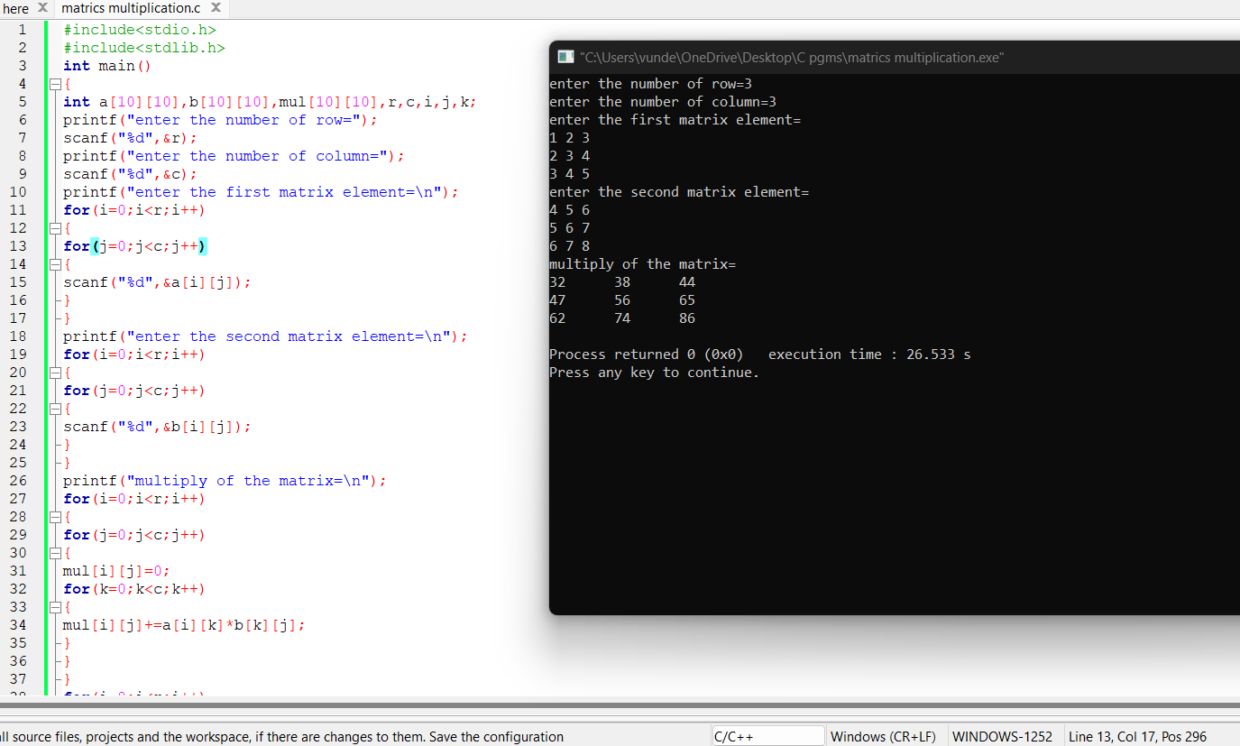

2) Write a C program to find Odd or Even number from a given set of numbers.

CODE :

#include <stdio.h>

int main()

{

int n;

printf("Enter number of elements in the array: ");

scanf("%d", &n);

int arr[n];

printf("Enter %d elements in the array: ",n);

for(int i=0;i<n;i++)

{

scanf("%d",&arr[i]);

}

printf("Even numbers in the array are: ");

for(int i=0;i<n;i++)

{

if(arr[i]%2==0)

printf("%d ", arr[i]);

}

printf("\nOdd numbers in the array are: ");

for(int i=0;i<n;i++)

{

if(arr[i]%2==1)

printf("%d ", arr[i]);

}

}

OUTPUT :

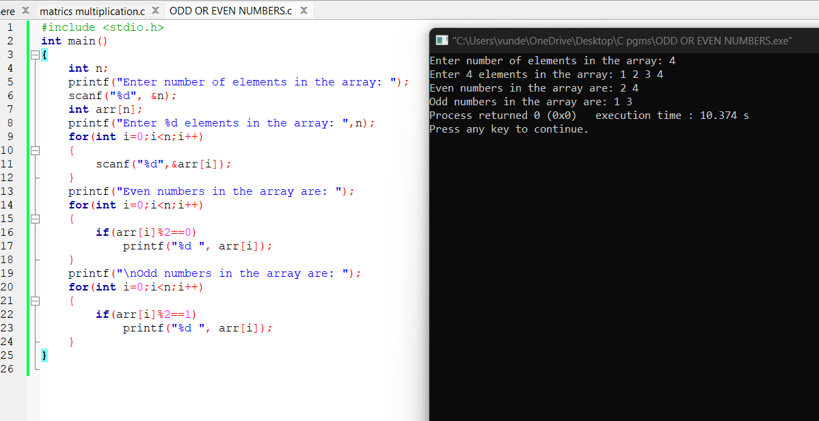

3) Write a C program to find Factorial of a given number without using Recursion.

CODE :

#include<stdio.h>

long int multiplyNumbers(int n);

int main() {

int n;

printf("Enter a positive integer: ");

scanf("%d",&n);

printf("Factorial of %d = %ld", n, multiplyNumbers(n));

return 0;

}

long int multiplyNumbers(int n) {

if (n>=1)

return n*multiplyNumbers(n-1);

else

return 1; }

OUTPUT :

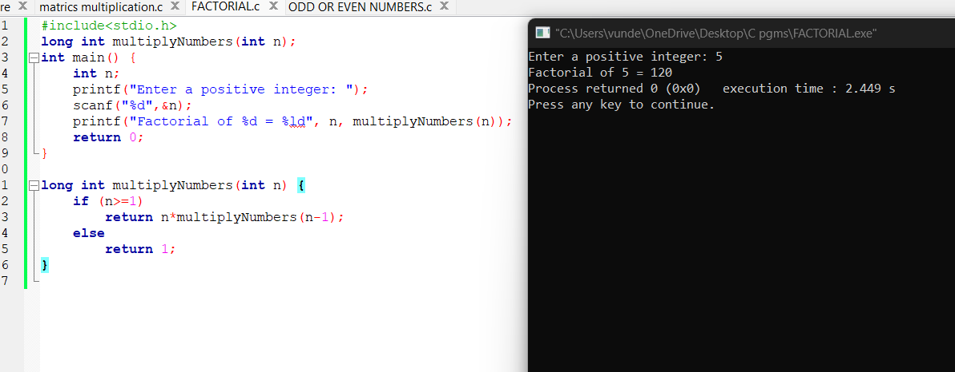

4) Write a C program to find Fibonacci series without using Recursion.

CODE:

#include <stdio.h>

int main() {

int i, n;

int t1 = 0, t2 = 1;

int nextTerm = t1 + t2;

printf("Enter the number of terms: ");

scanf("%d", &n);

printf("Fibonacci Series: %d, %d, ", t1, t2);

for (i = 3; i <= n; ++i) {

printf("%d, ", nextTerm);

t1 = t2;

t2 = nextTerm;

nextTerm = t1 + t2;

}

return 0;

}

OUTPUT:

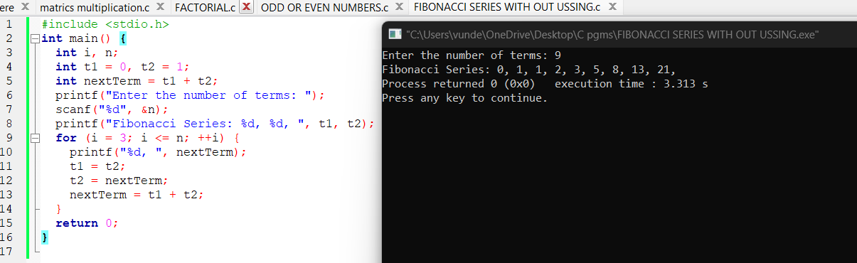

5)Write a C program to find Factorial of a given number using Recursion

Code :

#include <stdio.h>

#include <stdlib.h>

int main()

{

int n, i;

unsigned long long factorial = 1;

printf("Enter a number to find factorial: ");

scanf("%d",&n);

if (n < 0)

printf("Error! Please enter any positive integer number");

else

{

for(i=1; i<=n; ++i)

{

factorial *= i;

}

printf("Factorial of Number %d = %llu", n, factorial);

}

getch();

}

Output :

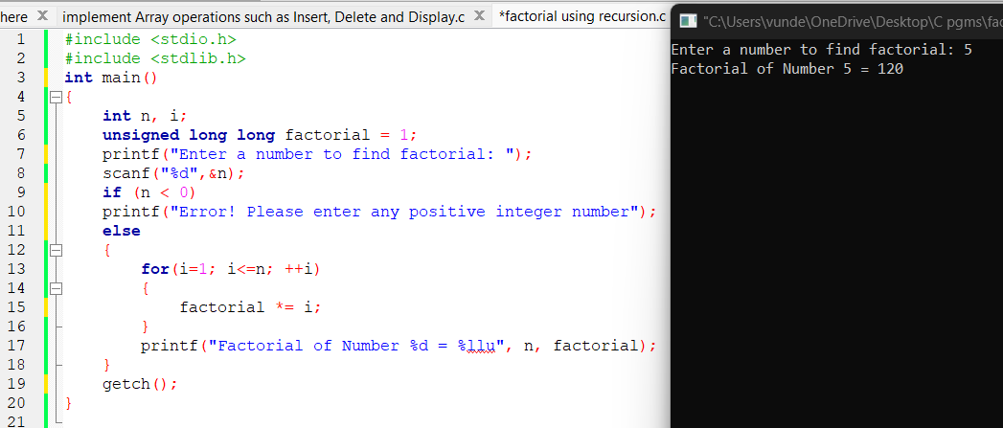

6) Write a C program to find Fibonacci series using Recursion

Output :

#include <stdio.h>

int fibonacci(int term);

int main(){

int terms, x;

printf("Enter number of terms in Fibonacci series: ");

scanf("%d", &terms);

printf("Fibonacci series till %d terms\n", terms);

for(x= 0; x< terms; x++){

printf("%d ", fibonacci(x));

}

return 0;

}

int fibonacci(int term){

if(term < 2)

return term;

return fibonacci(term-1) + fibonacci(term-2);

}

Output :

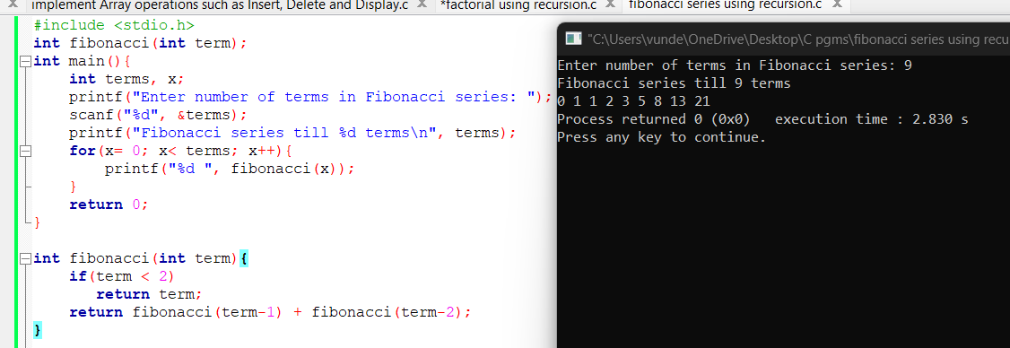

7) Write a C program to implement Array operations such as Insert, Delete and Display.

Code:

#include <stdio.h>

#define MAX 20

#include<stdlib.h>

int queue_array[MAX];

int rear = - 1;

int front = - 1;

void insert()

{

int add_item;

if (rear == MAX - 1)

printf("Queue Overflow \n");

else

{

if (front == - 1)

front = 0;

printf("\nEnter element : ");

scanf("%d", &add_item);

printf("\n%d is inserted in queue\n",add_item); printf("------------------------------\n");

rear = rear + 1;

queue_array[rear] = add_item;

}

}

void delete()

{

if (front == - 1 || front > rear)

{

printf("Queue Underflow \n");

return ;

}

else

{

printf("\nElement deleted from queue is : %d\n", queue_array[front]); printf("------------------------------\n");

front = front + 1;

}

}

void display()

{

int i;

if (front == - 1)

printf("Queue is empty \n");

else

{

printf("\nQueue is : ");

for (i = front; i <= rear; i++)

printf("%d ", queue_array[i]); printf("\n------------------------------");

printf("\n");

}

}

int main()

{

printf("Perform operations on queue\n"); printf("------------------------------\n");

printf("\tMenu"); printf("\n------------------------------\n");

printf("1. Insert element \n");

printf("2. Delete element \n");

printf("3. Display queue\n");

printf("4. Exit\n"); printf("------------------------------\n");

int ch;

while (1)

{

printf("Choose operation : ");

scanf("%d", &ch);

switch(ch)

{

case 1:

insert();

break;

case 2:

delete();

break;

case 3:

display();

break;

case 4:

exit(1);

default:

printf("Invalid operation \n");

}

}

return 0;

}

Output :

